Feedback
The ARCH That Supports Clinical Teaching Quality

ARCH

Ask...
what the learner felt about his or her performance - pros and cons

Reinforce...
parts of the self­ assessment the student got right

Correct...
errors in learner performance or self -assessment

Help...
the learner devise a plan for follow­ up or next steps

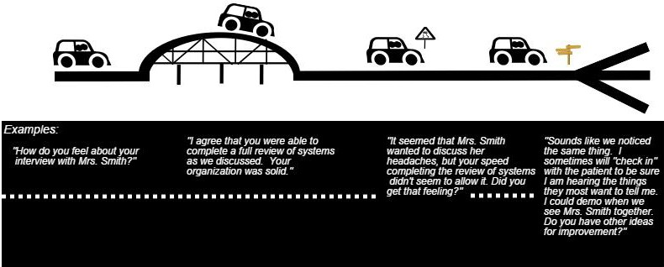
Principles of Feedback:
a
Establish learner andpreceptor expectations Limit feedback to 2-3 specific behaviors/session Positive feedback is as important
When to Give Feedback:
e
Immediate is Best End of the day
End of the rotation-summative

Medical learners maymiss akey finding or communicate ineffectively - not meeting established standards or expectations. Or they may perform very well on a specific task. Either way. it's the preceptor's job to guide or reinforce the student'sbehavior wijhdirect feedback. meaning that it's clear. behavior-specific. timely and received.
Preceptors are likely to deliver direct feedback when using aneasy-to-remember model- such as ARCH.
Before our preceptor and learner drive across the ARCH (above)- preceptors must know that context makes a big difference in feedback's effectiveness. One major element of context: establish and communicate learner and teacher expectations! Sometimes this is called "priming' or·setting the stage•.
•

Reference
Baker D.. ARCH F'eedback Model for Clinical Teachers. The Orange Grove: Florida's Oigital Library. accessed June l. 2015 at
http,//florida.theorangegrove.org/og/items/f08dbd67-ca07-Scfe-Oa58-
8a50784ee6c6/1/
Created by Wise FM: Kjer-sti Knox.MO. Jeffrey Morzinski. PhD& Melissa Stiles, MD. Published July 2015 as part of WtSE FM (Wisconsin Institute of Scholars & £ducators in FamilyMedicine)1a statewide facul develo ment collaborative affiliated with:

